

PHYSICS

YEAR 11

Unit 1

2015

Name:_____________________________________

Time allowed for this paper:
Reading time before commencing work 10 minutes
Working time for paper 2 hours

Materials required/recommended for this paper
To be provides by the supervisor
This Question/Answer Booklet
Formulae and Data Booklet

To be provided by the candidate
Standard items: pens, pencils (including coloured), sharpener, correction fluid, eraser, ruler, highlighters.
Special items : up to three non-programmable calculators approved for use in the WACE examinations, drawing templates, drawing compass and a protractor.

STRUCTURE OF THE PAPER

Section | No. of  Questions | No. of questions  to be attempted | Suggested working time  (minutes) | Marks available | Proportion of  exam total
1: Short Answers | 15 | ALL | 50 | 54 | 30%
2: Problem Solving | 9 | ALL | 90 | 90 | 50%
3: Comprehension and  Interpretation | 2 | ALL | 40 | 36 | 20%

INSTRUCTIONS TO CANDIDATES

Write your answers in the spaces provided beneath each question. The value of each question (out of 180) is shown following each question.

The enclosed Physics: Formulae and Constants Sheet may be removed from the booklet and used as required.

Calculators satisfying conditions set by the School Curriculum and Standards Authority may be used to evaluate numerical answers. The calculator cannot be a “graphics” calculator.

Answers to questions involving calculations should be evaluated and given in decimal form. Final answers should be given up to three significant figures and include appropriate units where appropriate. Despite an incorrect final result, credit may be obtained for method and working providing these are clearly and legibly set out.

Questions containing specific instructions to show working should be answered with a complete, logical, clear sequence of reasoning showing how the final answer was arrived at; correct answers which do not show working will not be awarded full marks.

Questions containing the instruction "ESTIMATE" may give insufficient numerical data for their solution. Show your working or reasoning clearly. Give final answers to a maximum of two significant figures and include appropriate units where applicable.

SECTION ONE – SHORT RESPONSE

Marks allocated: 54 marks out of a total of 180 (30%)

This section has 15 questions. Answer all questions.
Answers are to be written in the space below or next to each question.
Suggested working time: 50 minutes
Question 1 (4 marks)
In the context of heat transfer explain how conduction and convection differ from radiation using the kinetic theory of matter.

Question 2 (3 marks)
How much heat would be absorbed by a person’s skin if they were to come into contact with 10.0 g of steam at 100°C? (skin temperature is 37 ºC).

Question 3 (4 marks)
(a) Sketch a diagram of a circuit that has a total resistance of 15.0 Ω, consisting of only 10 Ω
resistors. Include a power supply and a switch in the circuit (2 marks)

(b) Calculate the potential difference required to provide a total current of 1.5 A through the circuit. (2 marks)

Question 4 (4 marks)
You are given two samples of radioactive waste.

 | Sample A | Sample B
Radioactive constituent | strontium - 90 | hydrogen - 3
Amount of material | 6.0 x 1020 atoms | 6.0 x 1020 atoms
Half-life | 29 years | 12 years
Emission type | High energy β - particles | Low energy β - particles
Does this material accumulate in the body? | Yes. Deposits in bone, close to marrow. | Yes. Fairly even distribution over the body.

(a) Which of the two samples would have the higher activity? Explain. (2 marks)

(b) Which of the two samples would pose the greater health risk due to radiation if accidentally
swallowed? Explain. (2 marks)

Question 5 (4 marks)
While checking for radioactive leaks, a worker discovers a drum of what he thinks is radioactive waste. When tested at a set distance the reading on his detector measures 242 Bq. If the half life of the waste is 5.0 x 10⁴ years, calculate how long it will take to produce a reading of 8.0 Bq.
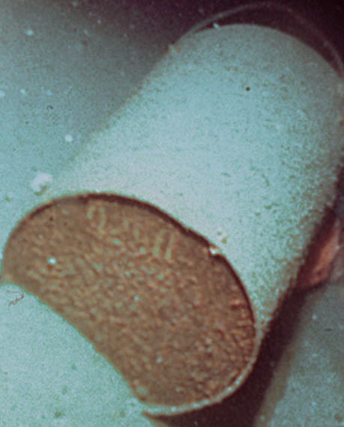

Question 6 (4 marks)
A cricketer is fielding on a very hot day. She calls for a runner to bring her a towel soaked in water. She places the towel on her head and after a short time she feels the cooling effect of the towel.

(a) Briefly explain how a wet towel can keep a person cool? (2 marks)

(b) Explain how the effectiveness of the wet towel would change in humid conditions.
(1 mark)

(c) State one factor that could be changed to increase the rate of cooling. (1 mark)

Question 7 (4 marks)
Use a diagram to explain the concept of electrical current, potential difference and resistance and explain how an electrical current is established.

Question 8 (3 marks)
Measurements of current flowing through a non-ohmic conductor as the potential difference is changed, are recorded and graphed. The graph is below.

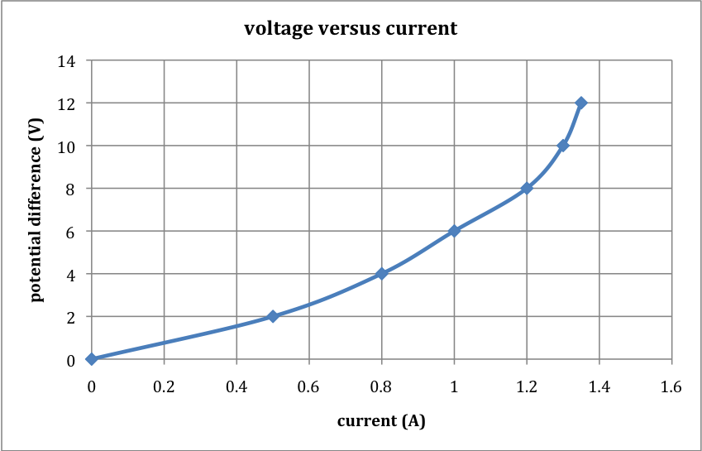

(a) Explain what is meant by the term ‘non-ohmic’. (2 marks)

(b) Using the graph determine the resistance when the potential difference is 10.0 V. (1 mark)

Question 9 (3 marks)
A geology student decides to measure the specific heat capacity of a sample of molten rock using the following steps. He:
- Prepares a bucket of water.
- Measures the temperature of the water.
- Records the mass of the bucket plus water.
- Plunges the molten rock into the water.
- Measures the final temperature of the water.
- Measures the combined mass of the bucket, water and solidified rock.
- Performs a calculation using Heat gained = Heat lost, and the formula Q = m c ΔT

State 3 reasons why this method would NOT give an accurate result.

Question 10 (2 marks)
The radiation emitted by the isotope Caesium – 137 can be used to treat food to increase its shelf life. Calculate the amount of energy absorbed by 2.00 kg of meat when it is given a dose of
2500 Gy.

Question 11 (5 marks)
(a) In the spaces below draw two circuit diagrams which consist of one 1.5 V cell powering two light globes.
Circuit 1: Two globes in series with the 1.5 V cell.
Circuit 2: Two globes in parallel with the 1.5 V cell.

Circuit 1: Series circuit (1 mark) | Circuit 2: Parallel circuit (1 mark)

(b) If the components in each of the circuits are identical, which circuit will have the brighter light globes? (1 mark)

(c) Explain your answer to (b). (2 marks)

Question 12 (3 marks)
The radioisotope iodine -131 is used in medicine to treat some cancers. It has a half- life of
8.1 days. It decays into an isotope of xenon (Xe) by beta emission.
- Write an equation that represents this decay.

Equation ________________________________________ (2 marks)

(b) In terms of half life explain why iodine is useful in this application. (1 mark)

END OF SECTION ONE
SECTION TWO QUESTIONS

Section Two: Problem-Solving 50% (90 marks)

This section contains 9 questions. Suggested working time 90 minutes
Answer the questions in the spaces provided.

Question 16 (14 marks)

Question 17 (10 marks)
A careless research student at a university, accidentally swallowed a radioisotope with an activity of 10.0 kBq. The material swallowed has a very long effective half-life, so assume that the activity will not change appreciably during the student’s lifetime. Each decay of the isotope releases 1.55 x 10-13 J of energy into the body. Also assume that all of the energy is absorbed by the student’s body and that the radioisotope is not eliminated.


(a) Calculate the amount of energy absorbed in one year. (1 year = 365 days) (2 marks)

(b) If the student has a mass 55.0 kg, determine the energy absorbed per kg in one year.
(2 marks)

(c) Calculate the absorbed radiation dose in grays per year. (2 marks)

(d) Assume that the ingested radioisotope is an alpha emitter.
(i) What is the equivalent absorbed radiation per year? (2 marks)

(ii) Should the student be concerned about his yearly radiation exposure?
Justify your answer. (2 marks)

Question 18 (7 marks)
A student heated a 750.0 g solid sample in an insulated container. An electric heating coil supplied heat energy at a rate of 20.0 J s⁻¹. She measured the temperature of the substance at half-minute intervals. The data was then graphed as shown below.
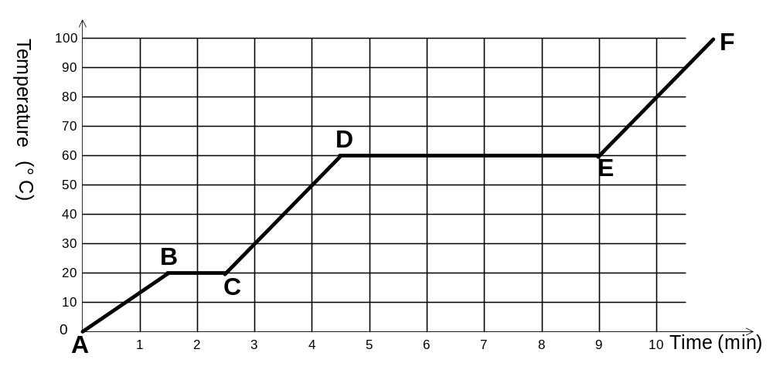

(a) Which section (A-B, B-C, etc) of the graph represents: (2 marks)

(i) the solid warming up to its melting point?

(ii) the gaseous substance increasing in temperature?

(b) Which sections of the graph represent stages where: (2 marks)

(i) the average kinetic energy of the particles was increasing?

(ii) the potential energy of the particles was increasing, whilst their kinetic energies remained
constant?

(c) ESTIMATE the quantity of heat required to convert 1.0 kg of the solid, at its melting point, to a
liquid. (3 marks)

Question 19 (13 marks)
In order to determine the specific heat of an unknown liquid students were encouraged to first find the heat generated by a Bunsen burner flame and then, later, using that same flame to heat a known mass of the unknown liquid. A diagram of the apparatus is shown below.

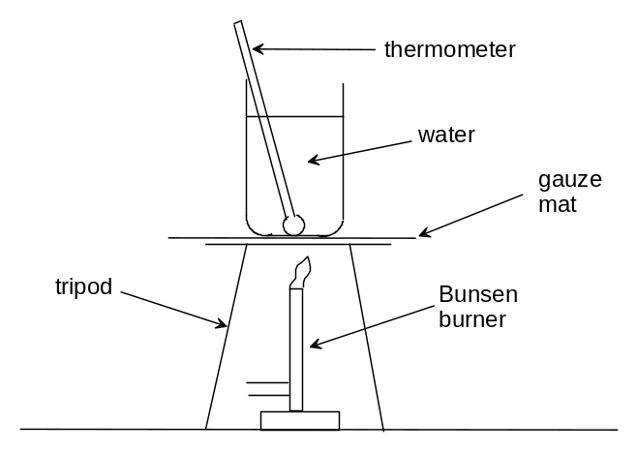

(a) List two good techniques a student would perform in this preliminary part of the experiment.
(2 marks)

Initially the water was heated with the Bunsen burner and the temperature rise recorded.

Mass of water (kg) | 0.50
Initial Temp of water ( ⁰C) | 23.0
Final Temp of water ( ⁰C) | 57.0
Change in temp of water ( ⁰C)
Time for which water was heated (s) | 260.0

(b) Calculate the quantity of heat generated by the Bunsen burner assuming no loss of energy to the
surroundings. (1 mark)

(c) Calculate the average power of the Bunsen burner. (2 marks)

(d) Before replacing the water with the unknown liquid the student was asked to list the main sources
of error while calculating the power of the Bunsen burner flame. List two possible sources of error. (2 marks)

The water was replaced by the unknown liquid and the procedure repeated. The results were
recorded in the table below.

Mass of unknown liquid (kg) | 0.41
Initial Temp of unknown liquid (⁰C) | 23.0
Final Temp of unknown liquid (⁰C) | 66.0
Change in temp of unknown liquid (⁰C)
Time that unknown liquid was heated (s) | 120.0

(e) In order for the results to be accurate, list two conditions that the students should
have taken care to duplicate. (2 marks)

(f) Determine the specific heat of the unknown liquid showing all your calculations. (4 marks)

Question 20 (10 marks)

The diagram below shows a schematic view of a nuclear power plant that underwent meltdown in the 1970s.
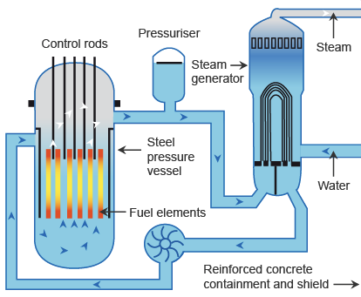
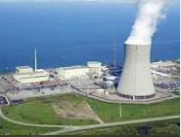

(a) Explain the purpose of the control rods, and how they are used to achieve their purpose.
(2 marks)

(b) Initial radiation exposure in contaminated areas of the reactor was due to short-lived iodine-131;
later caesium-137 was the main hazard. 93.5% of the Cs-137 parent isotope beta decays to Ba-137
with a half life of 30.17 years. In turn the Ba-137 decays with a half-life of 2.55 minutes, emitting
gamma radiation.

(i) Write a decay equation to represent the major decay of Cs-137 to Ba-137. (1 mark)

(ii) Write a decay equation to represent the decay of Ba – 137 when it has a half life of
2.55 minutes (1 mark)

The major fuel source for the reactor was enriched uranium containing 1.8% U-235, which underwent decay by a series of different reactions to produce 950 MW of electrical energy output.

(c) Calculate the mass of U-235 that underwent decay in the reactor every day, assuming that it operated at 40% efficiency.
(One U-235 nucleus has a mass 3.90625 x 10⁻²³ kg, and one decay event releases 200 MeV of
energy.) (6 marks)

Question 22 (11 marks)
The Carbon-Nitrogen-Oxygen (CNO) cycle is a complex set of fusion reactions by which stars convert hydrogen to helium. One of the reactions in the CNO cycle is shown below.

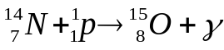

(a) Use the data in the table below to calculate the energy (in MeV) released in this reaction.
(2 marks)

Particle | Nitrogen-14 | Proton | Oxygen-15
Mass (u) | 13.999234 | 1.00728 | 14.998677

(b) Mass is converted to energy in nuclear reactions. In what form(s) could this energy exist?
Describe two examples. (2 marks)

The graph below shows the binding energy per nucleon versus mass number for the nuclei of some common isotopes.

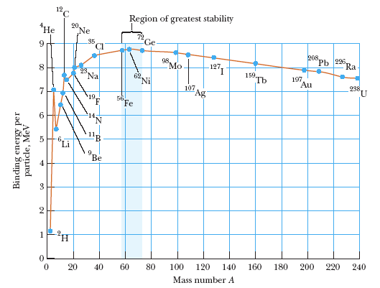

(c) In the context of nuclear physics, what does binding energy measure? (2 marks)

(d) The oxygen-16 nucleus has a mass of 15.990526 u, a proton has a mass of 1.00728 u and a neutron
has a mass of 1.00867 u. Calculate the average binding energy per nucleon for the oxygen-16
nucleus in MeV. (3 marks)

(e) Does your answer agree with the accepted value for the average binding energy per nucleon for the oxygen-16 nucleus? Explain your answer by making reference to the graph above. (2 marks)

Question 23 (11 marks)
A simplified diagram of a refrigerative air-conditioner for a house is shown below. A low boiling point, volatile hydrocarbon, called the refrigerant, is circulated through the pipes of the air-conditioner unit.

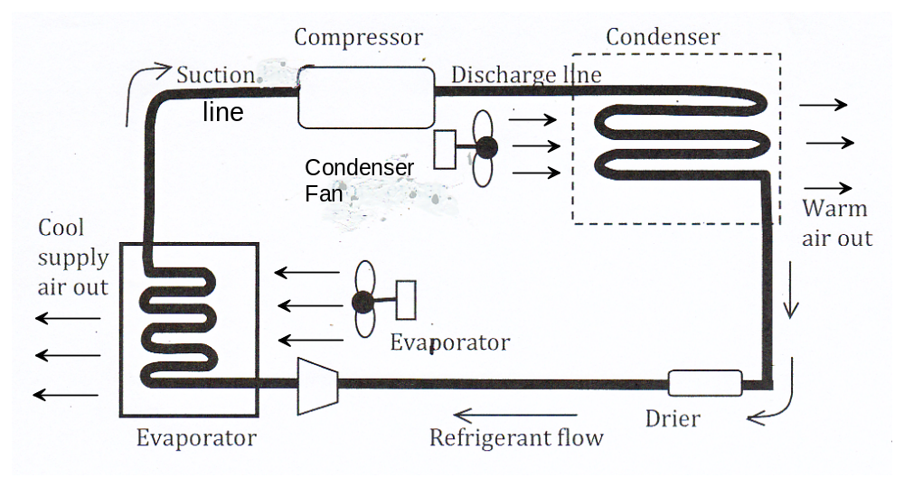

(a) As the refrigerant follows the suction line it enters the compressor. Describe the changes in
temperature, pressure and physical state of the refrigerant as it leaves the compressor and enters the
condenser. Your answer must refer to the latent heat of vaporisation of the refrigerant.
(2 marks)

(b) Where is the condenser unit placed in relation to the layout of the house? (1 mark)

(c) What is the purpose of the condenser fan? (1 mark)

(d) The expansion valve is not shown on this diagram. Explain where it would be placed in the circuit
and also explain its function. (2 marks)

(e) Explain the role of latent heat of vaporisation within the evaporator unit and explain how cool air is
supplied to the house. (3 marks)

(f) Describe 2 separate factors that should be considered when choosing a suitable refrigerant for this
type of air conditioner. (2 marks)

Question 24 (6 marks)
(a) Use calculations to demonstrate which has the greater resistance, a 60 W lamp or a 75 W lamp,
used in a 240 V mains supply. (4 marks)

(b) 75 W lamps are gradually being replaced with “smart” lamps that manufacturers claim deliver the
same power as the older incandescent globe. The new “smart” lamp has a rating of about 18 W.
Describe two advantages of “smart” lamps compared to incandescent lamps. (2 marks)

END OF SECTION TWO

SECTION THREE QUESTIONS

Marks allocated: 36 marks out of a total of 180 (20 %)
This section has two questions. Answer both questions. Answers should be written in the spaces provided.
Suggested working time – 40 minutes.

Question 25 (18 marks)
Thermal Conductivity
Conduction as heat transfer takes place if there is a temperature gradient in a solid or stationary fluid medium.
Energy transfers from more energetic to less energetic molecules when neighboring molecules collide. Heat flows in the direction of decreasing temperatures since higher temperatures are associated with higher molecular energy.
Metals have a higher heat transferability, or thermal conductivity, than wood. If you want to keep something cold the best idea is to wrap it in something that does not have a high heat transferability, or high thermal conductivity, this would be an insulator. Ceramics, and polymers are usually good insulators, but you have to remember that polymers usually have a very low melting temperature. That means if you are designing something that will get very hot the polymer might melt, depending on its melting temperature.

The coefficient of thermal conductivity (k) is a constant value that is assigned to materials that conduct heat and it varies from material to material. The coefficient can be calculated using an equation based on Fourier’s Law. The equation expresses conductive heat transfer.

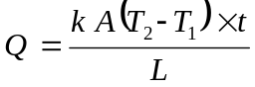…………………………….. equation 1

where
Q = heat transfer (J)
A = heat transfer area (m²)
k = thermal conductivity of the material Wm⁻¹ ºC⁻¹
(T₂ – T₁) = temperature difference across the material ( ºC)
t = time (s)
L = material length (m)

If a metal is to be investigated for its coefficient of thermal conductivity then values of Q, A, T₂, T₁, t and L need to be measured and manipulated in the Fourier Equation. (equation 1).
Rather than taking just one measurement of the variables, researchers usually take a number of measurements and use graphing techniques to arrive at the final value for k. In reality, a computer is used to process the data to produce the value.
Below is a set of measurements that have been recorded by a team of students in an effort to calculate the coefficient of thermal conductivity of a metal.

In this investigation the following results were obtained and tabulated. The metal bar to be investigated had length of 0.75 m, a cross sectional area of 0.035 m² and each trial was performed for 2.0 minutes.

(a) Complete the right hand column with the values for Τ₂ − Τ₁ (2 marks)
Heat in (Q)  (J x 10 ⁵) | Temperature  Τ₂ (ºC) | Temperature  Τ₁ (ºC) | Τ₂ − Τ₁
7.6 | 80 | 55
3.8 | 70 | 57
2.2 | 55 | 49
2.9 | 40 | 31
4.5 | 35 | 20

(b) Plot a graph of Heat in (y axis) against Temperature difference (Τ₂ − Τ₁) (x axis).
(4 marks)


(c) Use the graph to calculate a value for k, the thermal conductivity for this metal. (7 marks)

(d) Suggest a major variable that must be controlled for in performing this type of investigation.
(2 marks)

(e) Explain why researchers and scientists in general choose to perform more than one trial when
determining a final value. (2 marks)

(f) Suggest why polymers may be unsuitable to be used as an insulating material during this experiment. (1 mark)

